**Kareem Ibraheem**

**Day 3**

**Cont. Lab 2**

13. Create a folder called myteam in your home directory and change its permissions to read only for the owner.

14. Log out and log in by another user

15. Try to access (by cd command) the folder (myteam)

16. Using the command Line

* Change the permissions of oldpasswd file to give owner read and write permissions and for group write and execute and execute only for the others (using chmod in 2 different ways)

* Change your default permissions to be as above.



* What is the maximum permission a file can have, by default when it is just created? And what is that for directory.

A file -by default- is created with read permission for both owner and group, write permission for the owner, no permissions for other and no execute permission for anyone.  
A directory on the other hand -by default- has read and write permissions for the owner, read and execute permissions for the group and execute permission for others.

* Change your default permissions to be no permission to everyone then create a directory and a file to verify.

17. What are the minimum permission needed for:

* Copy a directory (permission for source directory and permissions for target parent directory)

Read and execute permissions for the source directory, write permission for the destination directory.

* Copy a file (permission for source file and and permission for target parent directory)

Read permission for the source file, write permission for the destination directory.

* Delete a file

write permission for the parent directory, no permissions needed for the file itself.

* Change to a directory

Execute permission for the destination directory.

* List a directory content (ls command)

Read and execute permissions.

* View a file content (more/cat command)

Only the read permission for the file.

* Modify a file content

Only the write permission for the file.

18. Create a file with permission 444. Try to edit in it and to remove it? Note what happened

file3 is not editable, nor it is removable.

19. What is the difference between the “x” permission for a file and for a directory?

This permission for a file means that the file is executable as a script or a command, whereas for a directory it means that its content is accessible and executable if appropriate permissions are present.

**Lab 3**

1. Using vi write your CV in the file mycv. Your CV should include your name, age, school, college, experience,...



2. Open mycv file using vi command then: Without using arrows state how to:

a. Move the cursor down one line at time.

J key

b. Move the cursor up one line at time.

K key

c. Search for word age

“/age”

d. Step to line 5 (assuming that you are in line 1 and file is more than 5 lines).

“5G” or “:5”

e. Delete the line you are on and line 5.

“dd” then “5delete”

f. How to step to the end of line and change to writing mode in one-step.

“$ + a key”

3. List the available shells in your system.

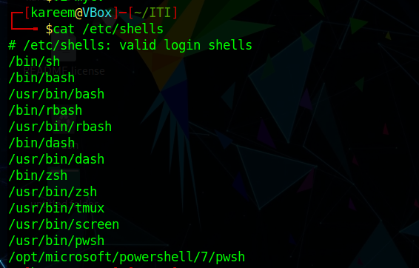

4. List the environment variables in your current shell.

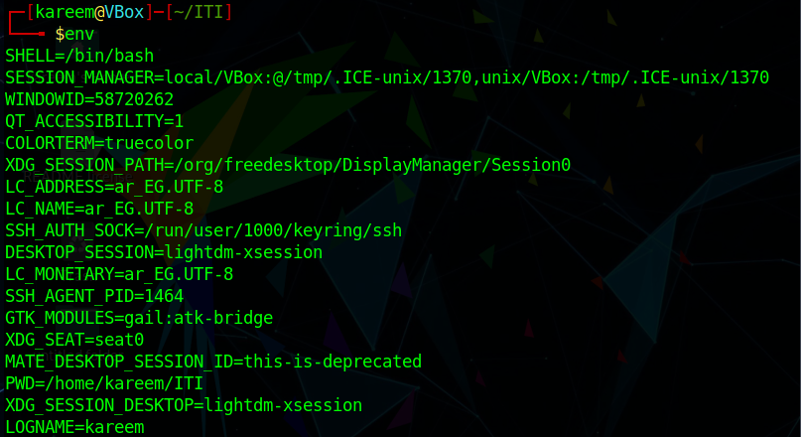

5. List all of the environment variables for the bash shell.

6. What are the commands that list the value of a specific variable?

Echo, env + grep, printenv + grep, set + grep.

7. Display your current shell name.

8. State the initialization files of: sh, ksh, bash.

Sh: .profile & .login

Ksh: .profile & .kshrc

Bash has many files, they’re as follows: /etc/profile, ~/.bash_profile, ~/.bash_login, ~/.profile, ~/.bashrc, ~/.bash_logout

9. Edit in your profile to display date at login and change your prompt permanently

10. Execute the following command : echo \

What is the purpose of \ ? it indicates that the proceeding char is a regular character instead of being interpreted as a predefined character.

Notice the prompt ”>” what is that? The echo \ command is waiting for further input to be typed.

and how can you change it from “>” to “:”? ???

11. Create a Bash shell alias named ls for the “ls –l” command

